OUTPUT:
Problem Statement: Privacy-Preserving Medical Data Generation
Context: High-quality datasets are essential for developing robust AI diagnostic tools in healthcare. However, strict privacy regulations (such as HIPAA and GDPR) and the inherent sensitivity of patient records often prevent the open sharing of real-world medical data, creating a significant bottleneck for researchers and developers.
The Challenge: Traditional anonymization techniques—such as removing names or IDs—are often vulnerable to re-identification attacks. Consequently, there is a critical need for a solution that preserves the statistical utility of a dataset (e.g., the correlations between glucose, BMI, and insulin levels) without exposing the actual identities or records of individual patients.
Proposed Solution: This project implements a Privacy Shield using a Variational Autoencoder (VAE). Unlike standard models that memorize data, a VAE learns the underlying probability distribution of the Pima Indians Diabetes Dataset.
Objectives:
- Generative Anonymization: Use a probabilistic encoder-decoder architecture to generate "Synthetic Twins"—artificial data points that are statistically identical to real patient records but do not belong to any specific individual.
- Statistical Fidelity: Ensure the synthetic data maintains the same correlations and distributions as the original features to remain useful for secondary research.
- Privacy Preservation: Leverage the latent space sampling and the Kullback-Leibler (KL) divergence regularizer to ensure the model generalizes rather than replicates sensitive training samples.

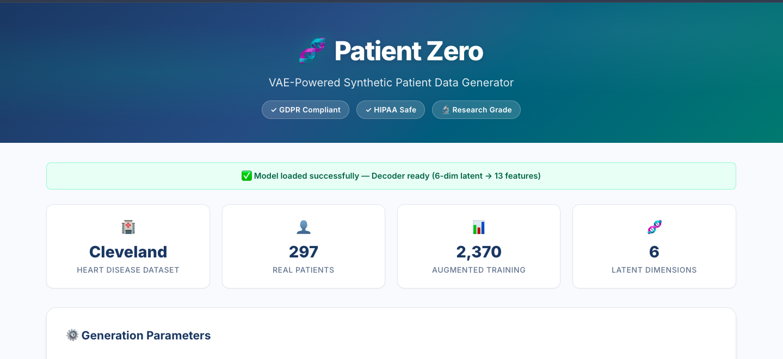

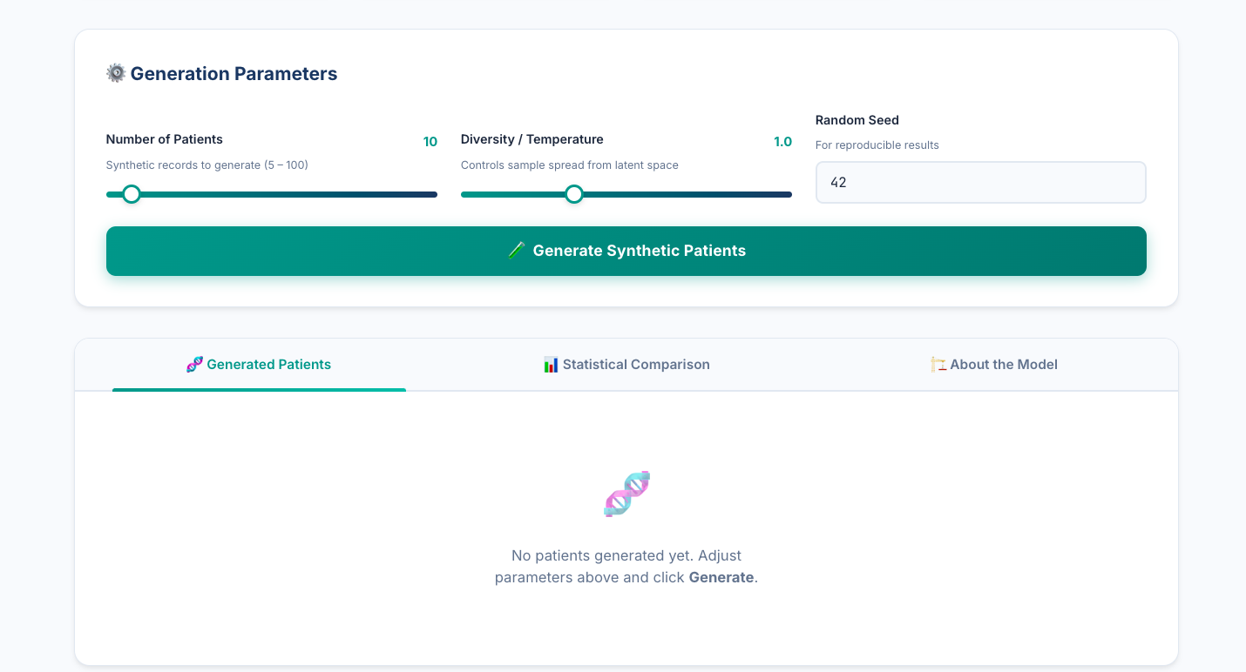

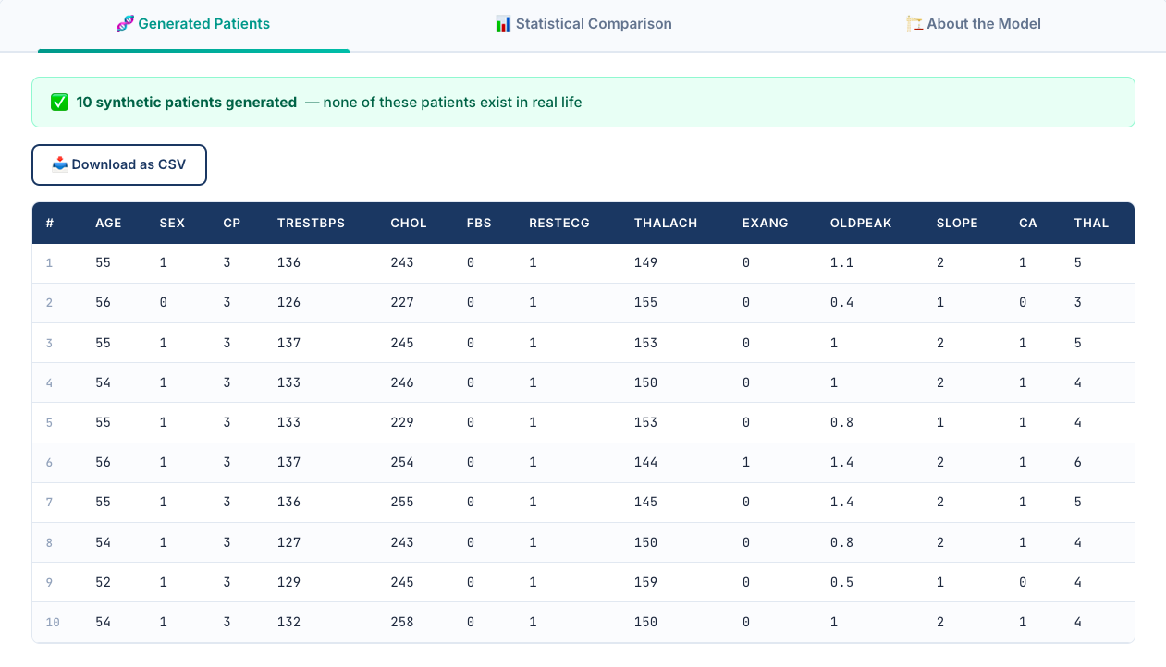

THIS PART COMPARES THE SYNTHETIC DATA WITH THE REAL DATA

